I am not sure how to make local host accessible to public, I create this website by using HTML, CSS, PHP, phpMyAdmin and some of JavaScript language and watch some tutorials. Additionally, for the connection and data to work users or testers need to have XAMPP and put the file in the htdocs, and most of my website using w3school template so without internet some pages of website cannot function normally. Furthermore, I have some proof of storage data in the pictures below to show that the website can be able to register, log in, chat and comment:

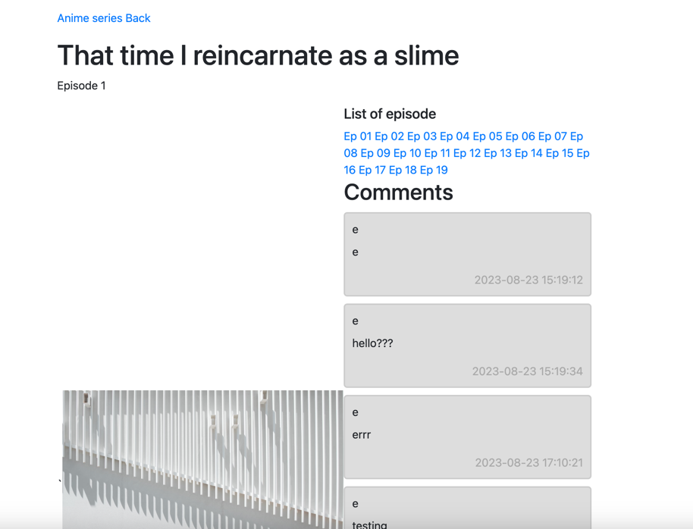

Comment Section

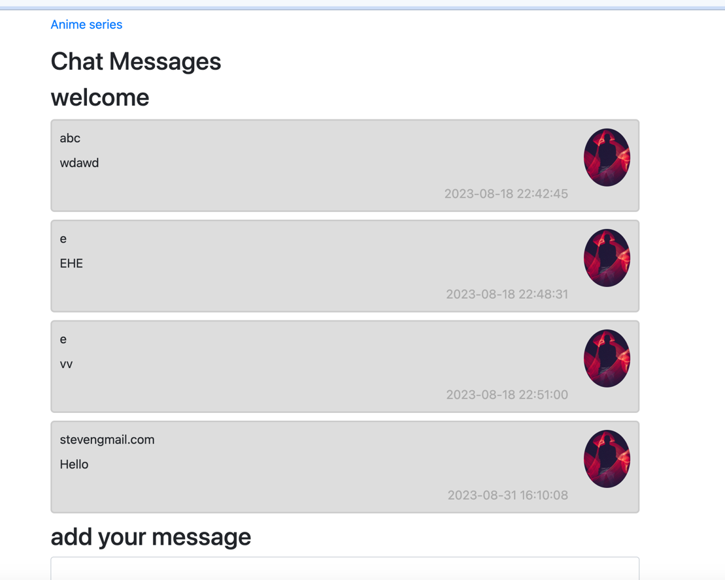

Chat group

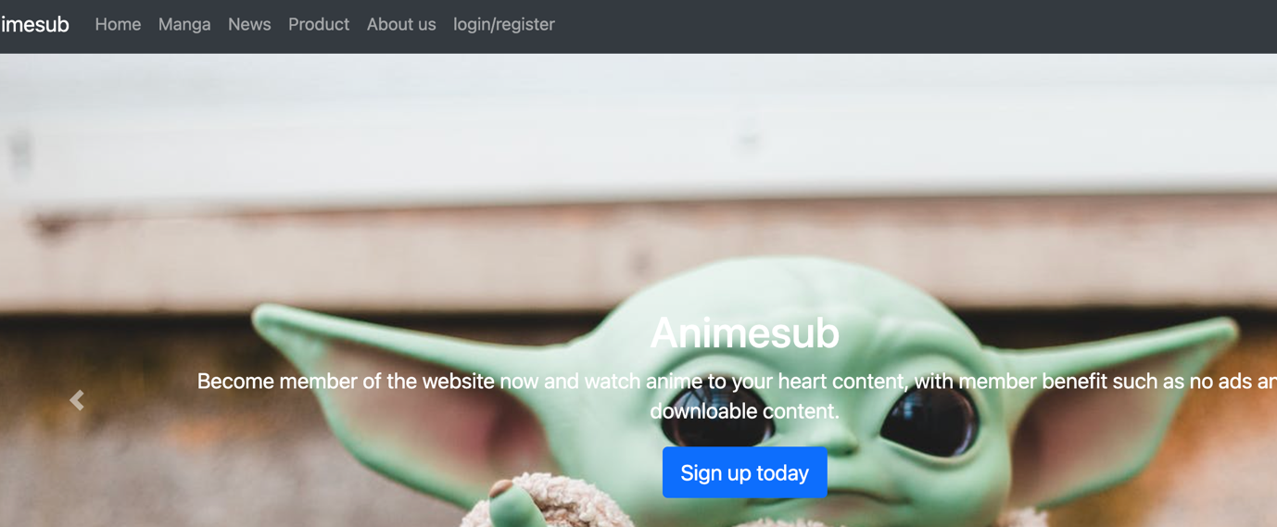

Before Register/Login

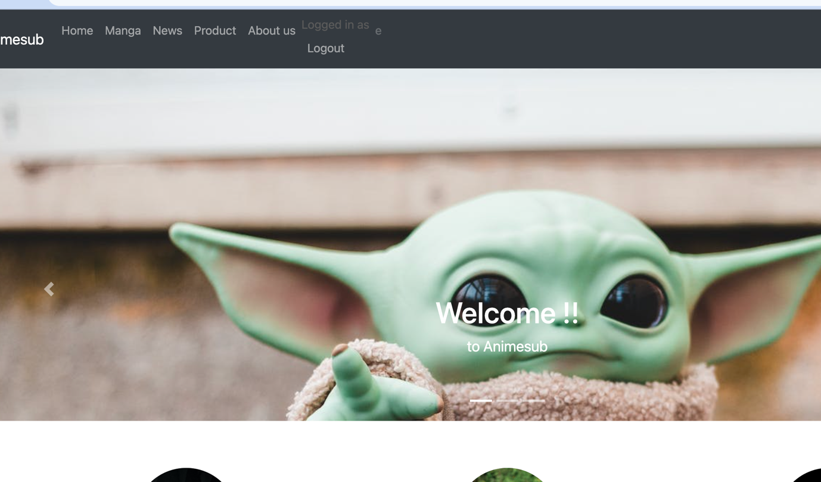

After login (and register successfully)

Data storage:

